HR Dataset SQL Queries

- List all employees with their department names and job roles.

SELECT e.name, d.department_name, j.job_role
FROM employees e
JOIN departments d ON e.department_id = d.department_id
JOIN jobs j ON e.job_id = j.job_id;
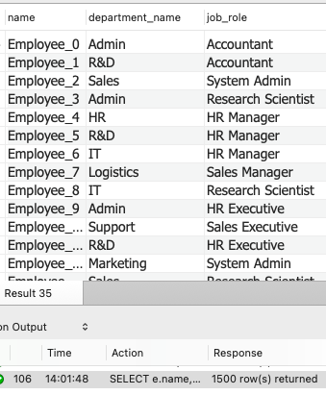

- Find employees who joined in the last 6 months.
SELECT name, hire_date
FROM employees
WHERE hire_date >= DATE_SUB(CURDATE(), INTERVAL 6 MONTH);

- Find total employees in each department
SELECT d.department_name , COUNT(e.employee_id) AS total_employes
FROM departments d
JOIN employees e ON d.department_id = e.department_id
GROUP BY d.department_name
ORDER BY total_employes DESC;
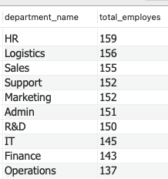

- Average salary by job role
SELECT j.job_role, ROUND(AVG(e.salary) , 2)AS avg_salary
FROM jobs j
JOIN employees e ON j.job_id = e.job_id
GROUP BY job_role

ORDER BY avg_salary DESC;
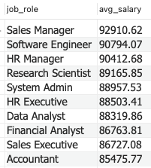

- Find employees earning above their job's max salary
SELECT e.employee_id, e.name , e.salary, j.max_salary
FROM employees e
JOIN jobs j ON j.job_id = e.job_id
WHERE e.salary > j.max_salary;
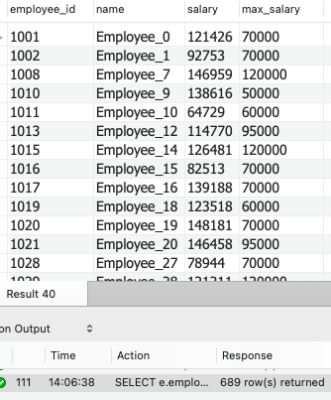

- Top 10 highest paid employees
SELECT employee_id, name, salary
FROM employees
ORDER BY salary DESC
LIMIT 10;
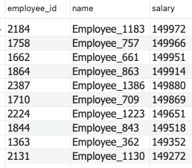

- Attrition rate by department
SELECT d.department_name,
SUM(CASE WHEN a.attrition = 'YES' THEN 1 ELSE 0 END) *100.0 /
COUNT(e.employee_id) AS attrition_percentage
FROM departments d
JOIN employees e ON d.department_id = e.department_id
JOIN attrition a ON e.employee_id = a.employee_id
GROUP BY d.department_name
ORDER BY attrition_percentage DESC;
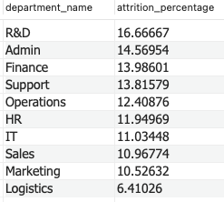

- List all employees who left the company
SELECT e.employee_id , e.name, a.reason
FROM employees e
JOIN attrition a ON e.employee_id = a.employee_id
WHERE attrition = 'YES';
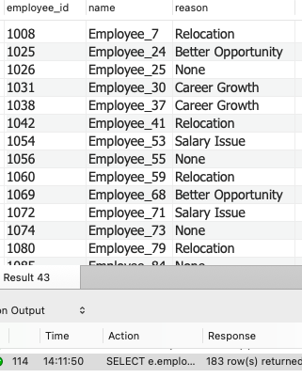

- Salary distribution (min, max, avg) per department
SELECT d.department_name,
MIN(e.salary) AS min_salary,
MAX(e.salary) AS max_salary,
AVG(e.salary) AS avg_Salary
FROM departments d
JOIN employees e ON d.department_id = e.department_id
GROUP BY d.department_name;
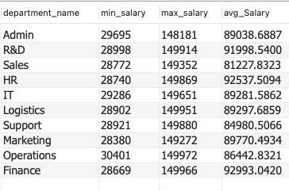

- Employee attendance summary
SELECT employee_id,
SUM(CASE WHEN status = 'Present' THEN 1 ELSE 0 END) AS days_present,
SUM(CASE WHEN status = 'Absent' THEN 1 ELSE 0 END) AS days_absent
FROM attendance
GROUP BY employee_id;
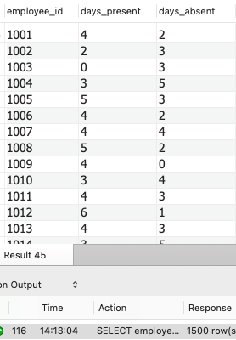

- Employees with lowest attendance
SELECT employee_id,
SUM(CASE WHEN status = 'Present' THEN 1 ELSE 0 END) AS present_days
FROM attendance
GROUP BY employee_id
ORDER BY present_days;
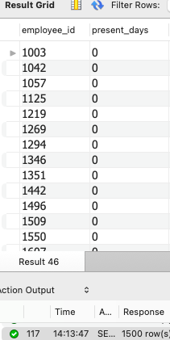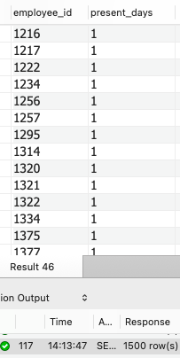

- Employees having salary above their department average
SELECT e.employee_id , e.name, d.department_name, e.salary
FROM employees e
JOIN departments d ON d.department_id = e.department_id
WHERE e.salary >
(SELECT Avg(salary)
FROM employees
WHERE department_id = e.department_id);
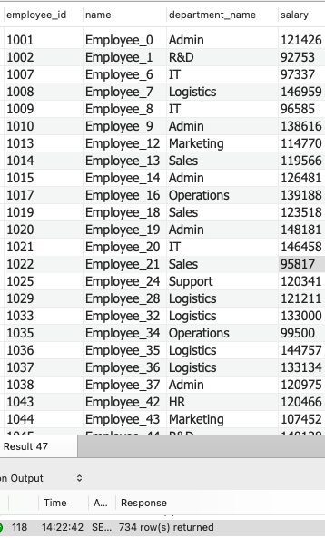

- Rank employees within each department
SELECT e.employee_id, e.name, e.salary, d.department_name,
RANK() OVER(PARTITION BY e.department_id ORDER BY e.salary DESC) AS dept_rank
FROM employees e
JOIN departments d ON e.department_id = d.department_id;
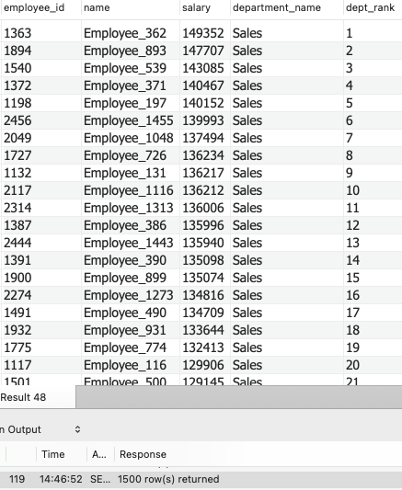
- Departments with highest absenteeism
SELECT d.department_name,
COUNT(*) AS total_absents
FROM departments d
JOIN employees e ON e.department_id = d.department_id
JOIN attendance a ON e.employee_id = a.employee_id
WHERE a.status = 'Absent'
GROUP BY d.department_name
ORDER BY total_absents DESC;
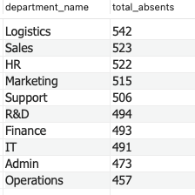

- Full employee analytic profile
SELECT e.employee_id, e.name, d.department_name, j.job_role,
e.salary, a.attrition, a.reason
FROM employees e
JOIN departments d ON e.department_id = d.department_id
JOIN jobs j ON e.job_id = j.job_id
JOIN attrition a ON e.employee_id = a.employee_id;

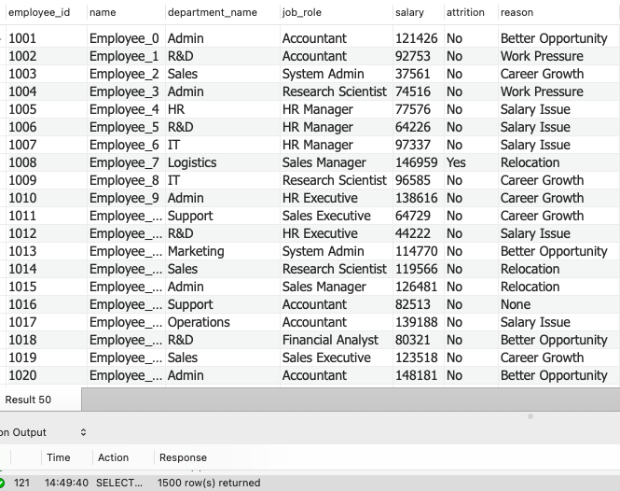

- Find the number of employees who left each month.
SELECT DATE_FORMAT(e.hire_date, '%Y-%m') AS month, COUNT(*) AS attrition_count
FROM attrition a
JOIN employees e ON a.employee_id = e.employee_id
WHERE a.attrition = 'Yes'
GROUP BY month
ORDER BY month;

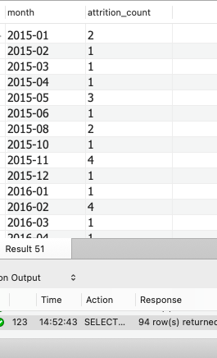

-- ADVANCE ANALYTICS

- Find the department with the highest attrition rate.

SELECT d.department_name,
COUNT(a.employee_id) * 100 / COUNT(e.employee_id) AS attrition_rate
FROM departments d
JOIN employees e ON d.department_id = e.department_id
JOIN attrition a ON e.employee_id = a.employee_id
GROUP BY d.department_name
ORDER BY attrition_rate DESC
LIMIT 1;

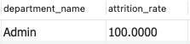

- Find the top 3 highest paid employees in each department (Window Function)
SELECT *
FROM(
SELECT e.name, d.department_name, e.salary,
DENSE_RANK() OVER (PARTITION BY e.department_id ORDER BY e.salary DESC) AS salary_rank
FROM employees e
JOIN departments d ON e.department_id = d.department_id
)ranked
WHERE salary_rank <= 3;

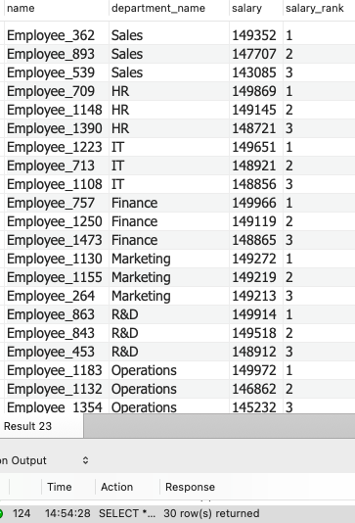

- Calculate year-over-year hiring growth (CTE + date functions)
WITH hires AS (
SELECT EXTRACT(YEAR FROM hire_date) AS year, COUNT(*) AS hires
FROM employees
GROUP BY EXTRACT(YEAR FROM hire_date)
)
SELECT year, hires,
hires - LAG(hires) OVER (ORDER BY year) AS year_growth
FROM hires;
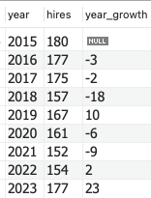

- Identify employees who earn above both their department AND job average salaries
SELECT e.employee_id, e.name, e.salary, d.department_name, j.job_role
FROM employees e
JOIN jobs j On e.job_id = j.job_id
JOIN departments d ON d.department_id = e.department_id
WHERE e.salary > (
SELECT AVG(salary) FROM employees WHERE department_id = e.department_id
)
AND e.salary > (
SELECT AVG(salary) FROM employees WHERE job_id = j.job_id)
;
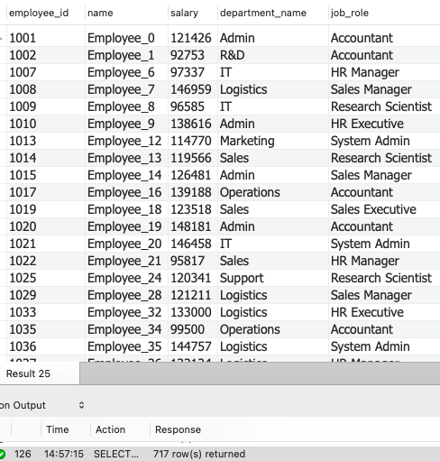

- Find departments with the highest absence rate
SELECT d.department_name,
(SUM( CASE WHEN status = 'Absent' THEN 1 ELSE 0 END) * 100 )/ COUNT(*)
As absence_rate
FROM departments d
JOIN employees e ON e.department_id = d.department_id
JOIN attendance a ON e.employee_id = a.employee_id
GROUP BY d.department_name
ORDER BY absence_rate DESC;
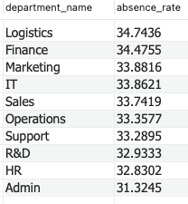

- Longest-serving employees (based on hire date)
SELECT employee_id, name, hire_date,
DATEDIFF(CURRENT_DATE, hire_date) AS days_in_company
FROM employees
ORDER BY hire_date ASC
LIMIT 20;

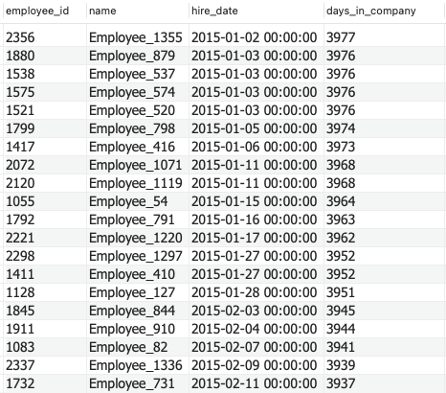

- Count employees who have never been absent (anti-join)
SELECT e.employee_id, e.name
FROM employees e
LEFT JOIN attendance a
ON e.employee_id = a.employee_id
AND a.status = 'Absent'
WHERE a.employee_id IS NULL;
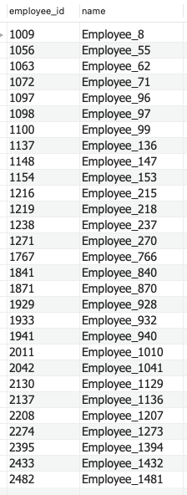

- Find employees most at-risk for attrition (salary < avg + attendance < avg)

SELECT e.employee_id, e.name, e.salary,
SUM(CASE WHEN a.status='Absent' THEN 1 ELSE 0 END) AS total_absent
FROM employees e
JOIN attendance a ON a.employee_id = e.employee_id
GROUP BY e.employee_id, e.name, e.salary
HAVING e.salary < (SELECT AVG(salary) FROM employees)
AND SUM(CASE WHEN a.status='Absent' THEN 1 ELSE 0 END)
> (SELECT AVG(absent_count)
FROM (
SELECT employee_id,
SUM(CASE WHEN status='Absent' THEN 1 END) AS absent_count
FROM attendance
GROUP BY employee_id
) sub);

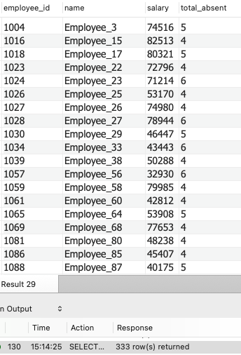

- List departments ranked by total salary expenditure
SELECT d.department_name,
SUM(e.salary ) AS total_salary,
RANK() OVER (ORDER BY SUM(e.salary) DESC) AS exp_rank
FROM employees e
JOIN departments d On e.department_id = d.department_id
GROUP BY d.department_name
ORDER BY total_salary;

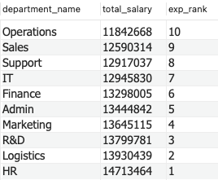
- Multi-level join: Full employee analytics profile
SELECT e.employee_id, e.name, d.department_name, j.job_role,
e.salary, a.attrition, a.reason
FROM employees e
JOIN departments d On e.department_id = d.department_id
JOIN jobs j ON e.job_id = j.job_id
JOIN attrition a ON e.employee_id = a.employee_id
JOIN attendance att ON att.employee_id = e.employee_id
GROUP BY e.employee_id, e.name, d.department_name, j.job_role,
e.salary, a.attrition, a.reason;

